ALGO Trading

- MACD (Moving Average Convergence Divergence) = EMA12 − EMA26
→ Shows momentum difference between short and long EMAs.
MACD = EMA(12) – EMA(26)
So first, you have two EMAs built from price:
- EMA(12): short-term trend (reacts faster)
- EMA(26): long-term trend (moves slower)
Their difference shows momentum — that’s the raw MACD line.

- Signal = 9-period EMA of MACD
→ Smooths out MACD for clearer buy/sell crossovers.
Signal Line = EMA(9) of the MACD line
Now we smooth the MACD line itself — not the price — using another EMA:
Signal(t)=EMA9​(MACD)
This “9” is called the signal period.
So the signal line is a 9-period exponential moving average of the MACD values (not of price). It acts as a “trigger” line for crossovers.
- How Signal is Calculated ?
Let’s say your MACD values for the last few ticks are: [-1.5, -1.2, -0.8, -0.4, 0.0, 0.3, 0.8, 1.0, 1.2]
These are the last 9 MACD readings (each derived from EMA(12) − EMA(26)).
The Signal Line is EMA(9) of MACD, not a simple average.
The Exponential Moving Average (EMA) formula is:
EMAt​= α×MACDt​ + (1−α)× EMA(t−1​)
Where
α= 2 / (N+1)​
Lets N= 9
Then
α= 2 / (9 +1)= 0.2
That means:
- 20% weight on the latest MACD value
- 80% weight on the previous Signal Line value

Initialize with SMA (first value)
- Before we have a previous EMA, we start by taking a Simple Average of the first 9 MACD values as the initial seed.
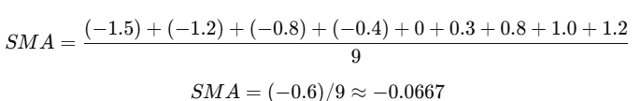
So our first Signal Line value = -0.0667.

Next tick — new MACD value arrives
Let’s assume the next MACD (newest) = 1.5
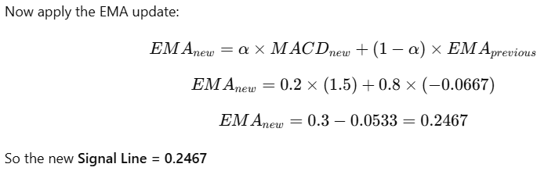

Next updates continue similarly
For each new MACD value:
Signal t​= 0.2× MACDt ​+ 0.8×Signal(t−1​)

- Hist (Histogram) = MACD − Signal
→ Visual measure of momentum strength.
→ Positive Hist = bullish momentum; Negative Hist = bearish.

Summary

Component | Formula | Period | Data Used | Meaning
Fast EMA | EMA(12) | 12 | Price | Short-term trend
Slow EMA | EMA(26) | 26 | Price | Long-term trend
MACD Line | EMA(12) − EMA(26) | — | Derived from price | Momentum indicator
Signal Line | EMA(9) of MACD | 9 | MACD values | Smoothed trigger line
Histogram | MACD − Signal | — | Derived | Visual strength of momentum

In Short:
- The MACD line responds to price changes.
- The Signal line responds to MACD changes.
- The Histogram (MACD − Signal) measures momentum difference.

Trade Logic
Entry Logic
If no open position:
- Enter Long (Buy) when:
  - MACD crosses above Signal and MACD > 0
(strong bullish trend confirmation)
- Enter Short (Sell) when:
  - MACD crosses below Signal and MACD < 0
(strong bearish trend confirmation)

